Git is a free, open-source version control system that helps developers track changes to their code, collaborate with others, and manage different versions of a project.
Think of Git like a save history for your files. Instead of saving files as project_v1, project_v2, and project_final, Git keeps a complete history of every change and lets you return to any previous version.
What Git is used for
- Track changes: See what changed, when, and by whom.
- Collaborate: Multiple people can work on the same project without overwriting each other's work.
- Branching: Create separate branches to develop new features or fix bugs without affecting the main project.
- Merge changes: Combine work from different branches once it's ready.
Basic Git workflow
- Create or clone a repository (project).
- Make changes to files.
- Stage the changes:
git add .
- Save a snapshot (commit):
git commit -m "Add login feature"
- Share your changes with others:
git push
Common Git commands
- git init – Start a new Git repository.
- git clone <url> – Copy an existing repository.
- git status – See which files have changed.
- git add <file> – Stage changes.
- git commit -m "message" – Save changes.
- git pull – Download the latest changes.
- git push – Upload your commits.
- git branch – List or create branches.
- git merge – Combine branches.
Git vs. GitHub
A common point of confusion is the difference between Git and GitHub:
- Git is the software that tracks changes on your computer.
- GitHub is an online platform that hosts Git repositories, making it easy to store code remotely and collaborate with others.
If you're new to programming, learning Git is one of the most valuable skills because it's widely used in software development and data science. I can also walk you through Git step by step with hands-on examples if you're interested.
Features of Git
1. Version Control System: Git keeps track of every change you make to your project files. You can go back to previous versions is any requirement arises.
2. Repositories: A Git repository (or repo) is like a project's central hub where everything related to your work is stored and managed. There are two main types:
- Local Repository: This is a copy of the repository which is stored in your computer. You can work on your project and make changes here.
- Remote Repository: This is stored on a server, like GitHub, where you and others can share and work on a project.
3. Commits: Every time you make changes and save them in Git, these are called commits. The repository keeps track of all the commits you have made.
4. Branches: A repository allows you to create Branches and work on new features and fixes. For example, you can have a "main" branch for stable code and a "feature" branch for new features you're developing.
5. Merging: Once you are done with the branches you have made, you can merge those branches into main branch. This adds the changes you have made in the rest of the project.
6. Cloning: Cloning is a process of making a complete copy of Git repository. It's like copying the entire project from central location ( like website) to your own computer.
Reasons to Choose Git
- Distributed System: Every developer has a complete local copy of the project, allowing for offline work and increased resilience.
- Performance: Git is fast and efficient, handling large projects with ease.
- Branching and Merging: Git's lightweight branching and easy merging facilitate parallel development and feature isolation.
- Collaboration: Tools like GitHub enhance team collaboration, code reviews, and project management.
- Track Changes: Git tracks changes and maintains a history, making it easy to revert to previous versions.
Steps to Setup a Git
Install Git: Download and install Git from the official Git website.
Configure Git: Set up your username and email.
git config --global user.name "Your Name"
git config --global user.email "your.email@example.com"
Create a Repository: Navigate to your project directory and initialize a Git repository.
git init
Make Your First Commit: Add files to the staging area and commit your changes.
git add .
git commit -m "Initial commit"
Basic Git Commands
- git init: Initializes a new Git repository.
git init
- git clone [URL]: Clones a remote repository to your local machine.
git clone [url]
- git add [file]: Stages changes to be committed.
git add [file]
- git commit -m "message": Commits the staged changes with a message.
git commit -m "Your commit message"
- git push: Pushes your commits to a remote repository.
git push origin branch-name
- git pull: Fetches and merges changes from a remote repository to your local repository.
git pull origin branch-name
- git status: Shows the status of changes in your working directory.
git status
Drawbacks
- Git can be complex to learn, especially for beginners.
- Some commands and operations can be difficult to understand and remember.
- Resolving conflicts when merging branches can be challenging.
- The local repository can take up significant space on your computer.
- Initial setup and configuration can be time-consuming.
- Git is less efficient at handling large binary files (e.g., videos, images).
Git Workflow
A Git workflow is a set of guidelines for using Git in a structured and efficient manner. Here’s a simple and common Git workflow:
- Clone Repository: git clone git@github.com:username/repository.git
- Create Branch: git checkout -b feature-branch-name
- Check Status: git status
- Stage Changes: git add filename or git add .
- Commit Changes: git commit -m "Add feature X"
- Push Branch: git push origin feature-branch-name
- Create Pull Request: On Github/other service
- Update Local Repository: git checkout main, git pull origin main
- Delete Branch: git branch -d feature-branch-name, git push origin --delete feature-branch-name
Commonly Used Version Control Tools
Version control tools help developers track changes, collaborate, and manage source code.
1. Git ⭐ (Most Popular)
The most widely used version control system today.
Features:
- Distributed version control
- Branching and merging
- Fast and lightweight
- Works offline
- Integrates with platforms like GitHub and GitLab
Used by: Most modern software and DevOps teams

2. Apache Subversion (SVN)
Apache Subversion
A centralized version control system where all code is stored on a central server.
Features:
- Simple to understand
- Central repository
- Good for smaller teams
Limitation:
- Requires server access for many operations
- Less flexible branching compared to Git

3. Mercurial
Mercurial
A distributed version control system similar to Git.
Features:
- Easy to learn
- Fast performance
- Good handling of large repositories
Limitation:
- Smaller community compared to Git

4. CVS
Concurrent Versions System
One of the earliest version control systems.
Features:
- Centralized repository
- Basic version tracking
Limitation:
- Outdated and rarely used today

5. Perforce
Helix Core
A commercial version control tool commonly used for very large projects.
Features:
- Handles huge binary files efficiently
- High performance
- Enterprise-grade security
Used by:
- Gaming companies
- Semiconductor industries
- Large enterprises

Comparison Table
Tool | Type | Popularity | Common Usage
Git | Distributed | ⭐⭐⭐⭐⭐ | Most software and DevOps projects
SVN | Centralized | ⭐⭐⭐ | Legacy enterprise projects
Mercurial | Distributed | ⭐⭐ | Some open-source projects
CVS | Centralized | ⭐ | Mostly obsolete
Perforce | Centralized | ⭐⭐⭐ | Large enterprise and game development
Which one should a DevOps Engineer learn?
- Git ✅ (Essential)
- SVN (Good to know for legacy projects)
- Perforce (Only if working in gaming or specialized industries)
For a DevOps career, mastering Git is far more important than the others because it is the standard tool used in almost every modern CI/CD pipeline.
Centralized Version Control System (CVCS) vs Distributed Version Control System (DVCS)
A version control system helps developers manage changes to source code. The main difference between CVCS and DVCS is where the repository and history are stored.
Feature | Centralized VCS (CVCS) | Distributed VCS (DVCS)
Repository Location | Stored on a central server | Each user has a complete copy of the repository
Internet Requirement | Usually required to work | Not required for most operations
Speed | Slower (depends on server communication) | Faster (operations happen locally)
Backup | Single point of failure | Every developer's machine acts as a backup
Commit History | Stored only on the server | Stored on every developer's machine
Branching and Merging | Limited and slower | Easy, fast, and widely used
Collaboration | Through a central server | Directly between repositories or through a remote server
Examples | SVN, CVS | Git, Mercurial
1. Centralized Version Control System (CVCS)
Architecture
Central Repository
│
┌────────┼────────┐
│ │ │
Developer1 Developer2 Developer3
How it works
- All code is stored on a central server.
- Developers check out files from the server.
- Changes are committed back to the server.
Advantages
- Easy to manage.
- Simple access control.
- Everyone works with the same central repository.
Disadvantages
- If the server goes down, developers cannot commit changes.
- If the server is lost and no backup exists, the entire history may be lost.
- Requires network connectivity for many operations.
Examples
- Apache Subversion (SVN)
- Concurrent Versions System (CVS)

2. Distributed Version Control System (DVCS)
Architecture
Remote Repository
│
┌──────────┼──────────┐
│ │ │
Developer1 Developer2 Developer3
(Full Copy) (Full Copy) (Full Copy)
How it works
- Each developer clones the entire repository.
- Developers can commit changes locally.
- Changes are shared with others by pushing to a remote repository.
Advantages
- Work completely offline.
- Faster commits, logs, and branching.
- No single point of failure.
- Easy branching and merging.
Disadvantages
- Slightly larger local storage requirement.
- Can be more complex for beginners.
Examples
- Git
- Mercurial

Example Scenario
Suppose three developers are working on a project.
In CVCS
Developer → Server → Developer
Every commit goes directly to the central server.
In DVCS
Developer → Local Repository → Remote Repository
Developers commit locally and push changes later.
What is a Fork in Git?
A fork is a copy of someone else's repository that is created under your own account on a Git hosting platform such as GitHub or GitLab.
Forking allows you to experiment with changes without affecting the original repository.
How Fork Works
Original Repository
│
▼
Fork Repository
(Your GitHub Account)
│
▼
Clone to Local Machine
│
▼
Make Changes
│
▼
Commit and Push
│
▼
Create Pull Request
│
▼
Original Repository
Why Use a Fork?
- Contribute to open-source projects.
- Experiment with code safely.
- Maintain your own copy of a project.
- Propose changes to the original project through a Pull Request (PR).
Fork vs Clone
Feature | Fork | Clone
Location | Creates a copy on your Git hosting account | Creates a copy on your local machine
Ownership | You own the forked repository | No change in ownership
Used For | Contributing to external projects | Working locally on any repository
Command Needed | Done through GitHub/GitLab UI | git clone <repository-url>
Example
Suppose you want to contribute to an open-source project:
- Fork the repository on GitHub.
- Clone your fork locally:
git clone https://github.com/your-username/project.git
- Make changes and commit them:
git add .
git commit -m "Fixed bug"
- Push changes:
git push origin main
- Create a Pull Request to the original repository.
Interview definition:
A fork is a server-side copy of another user's repository created under your own account, allowing you to make changes independently and contribute them back through a pull request.
Difference Between Git and GitHub
Many beginners confuse Git and GitHub, but they are different things.
Feature | Git | GitHub
What is it? | A version control system | A cloud-based platform for hosting Git repositories
Purpose | Tracks changes in source code | Stores and manages Git repositories online
Installation | Installed on your local machine | Accessed through a web browser
Internet Required | No, most operations work offline | Yes, internet is needed to access remote repositories
Developed By | Linus Torvalds | GitHub
Cost | Free and open source | Free and paid plans available
Main Functions | Commit, branch, merge, track history | Collaboration, pull requests, issues, code reviews

Git
Git is a Distributed Version Control System (DVCS).
It helps developers:
- Track file changes
- Create branches
- Merge code
- Revert to previous versions
- Work offline
Example Git Commands
git init
git add .
git commit -m "Initial commit"
git branch feature
git merge feature

GitHub
GitHub is a website that hosts Git repositories and provides collaboration features.
It allows developers to:
- Store repositories online
- Share code with others
- Review code changes
- Manage projects
- Contribute to open-source software
Common GitHub Features
- Repository hosting
- Pull Requests (PRs)
- Issues
- Actions (CI/CD)
- Discussions
- Wikis

How Git and GitHub Work Together
Developer Machine
│
│ Git Commands
▼
Local Git Repository
│
git push / git pull
▼
GitHub Repository

Simple Analogy
Imagine you're writing a book:
- Git is like the "Track Changes" feature in a word processor. It records every edit you make.
- GitHub is like an online library where you store the book, share it with others, and collaborate on writing it.

Interview Answer
Git is a distributed version control system used to track changes in source code, while GitHub is a cloud-based platform that hosts Git repositories and provides collaboration features such as pull requests, code reviews, and issue tracking.
In DevOps
- Git → Used for version control.
- GitHub/GitLab → Used as remote repositories and integrated with CI/CD pipelines.
For a DevOps engineer, learning Git commands first and then GitHub workflows (repositories, forks, pull requests, and actions) is the recommended approach.
Useful Git Commands and Basic Concepts
Last Updated : 23 Apr, 2026

Useful Git commands and basic concepts help in managing repositories, tracking changes, and handling version control efficiently in development workflows.
- Provides essential commands to track, commit, and manage changes in projects.
- Helps understand core concepts like staging, commits, and repositories.
- Enables efficient collaboration and version control management.
Setting up Git Repository
Create a Git repository and understand the basic steps involved in working with Git.
1. Create a Project Folder
Start by creating a folder that contains different types of files such as text files, Excel files, Markdown files, or source code folders. For simplicity, these files can initially be empty.
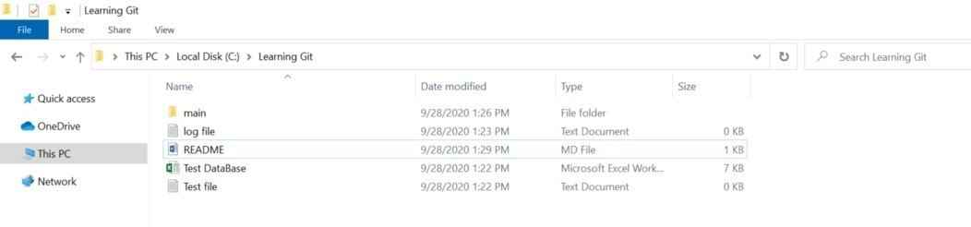
2. Choose a Tool
You can use:
- Git Bash to run Git commands
- VS Code with built-in Git support
Open Git Bash by right-clicking inside the folder and selecting “Git Bash Here”
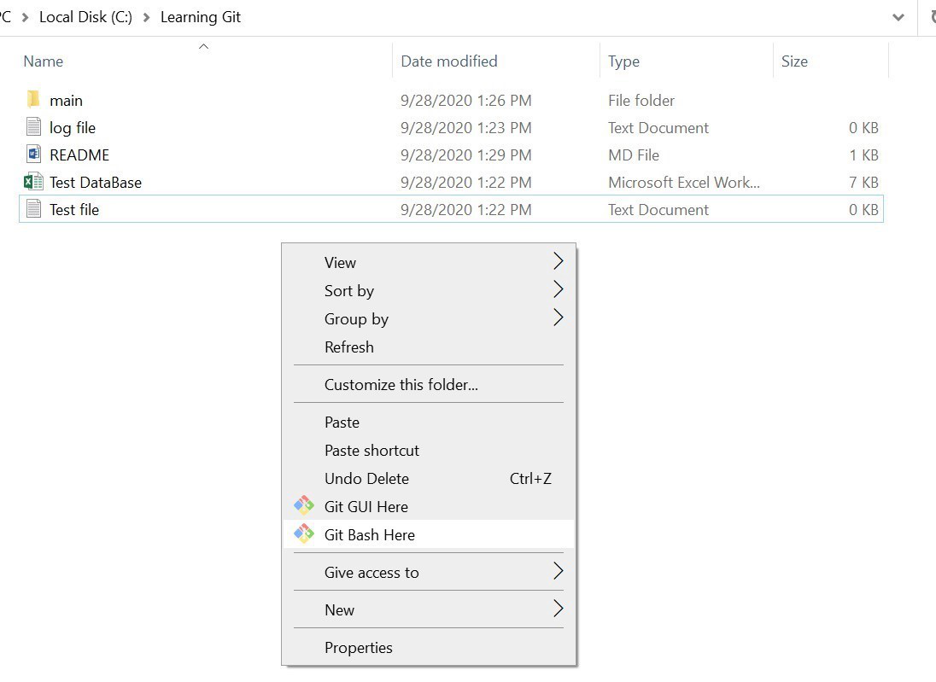
3. Initialize the Repository
Initialize the folder as a Git repository.
Command:
git init
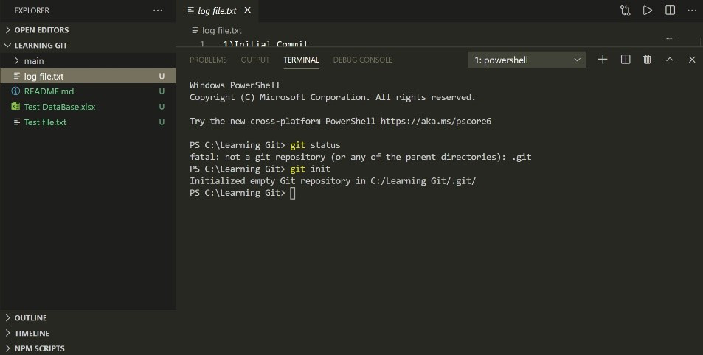
Note: Do not run this command again on an existing repository, as it may reinitialize it.
4. Stage Files
Add files to the staging area so that Git can start tracking them.
Command:
git add .
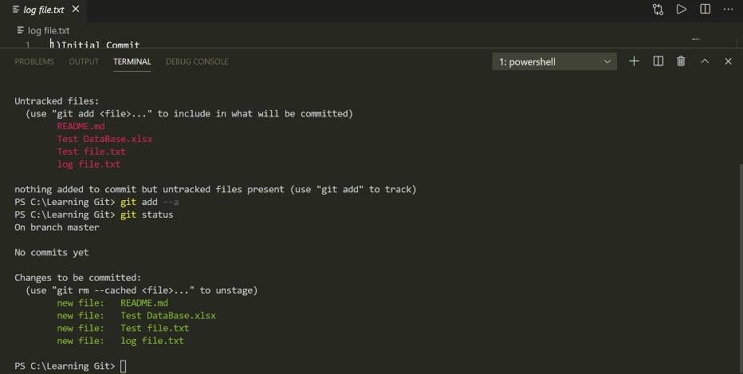
5. Create Initial Commit
Make the first commit to save the current state of your project.
Command:
git commit -m "Initial commit"
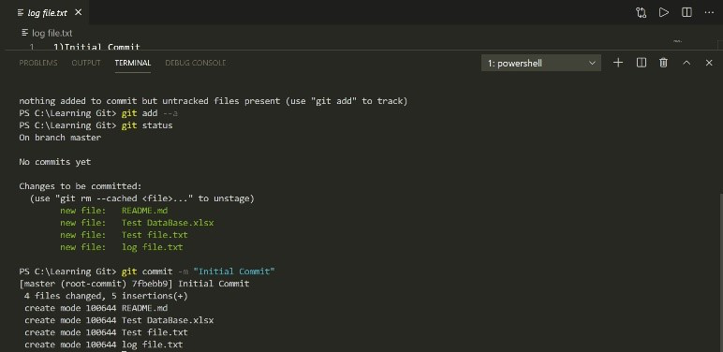
Useful Git Commands
These commands help manage repositories, track changes, and perform version control operations efficiently.
1. git init
Initializes a new Git repository in the current directory.
git init
2. git clone
Creates a copy of an existing remote repository.
git clone <repository-url>
3. git status
Displays the state of the working directory and the staging area. It shows which changes have been staged, which haven't, and which files are not being tracked by Git.
git status
4. git add
Adds changes from the working directory to the staging area.
git add <file>
To add all changes:
git add .
5. git commit
Records the changes in the staging area in the repository with a descriptive message.
git commit -m "Your commit message"
6. git log
Shows the commit history for the current branch.
git log
7. git branch
Lists all branches in the repository. The * indicates the current branch.
git branch
Creates a new branch:
git branch <branch-name>
8. git checkout
Switches to a different branch or restores files in the working directory.
git checkout <branch-name>
9. git merge
Merges changes from one branch into the current branch.
git merge <branch-name>
10. git pull
Fetches changes from a remote repository and merges them into the current branch.
git pull origin <branch-name>
11. git push
Uploads local commits to a remote repository.
git push origin <branch-name>
12. git remote
Manages the set of tracked repositories.
To add a new remote:
git remote add <name> <url>
13. git fetch
Downloads objects and refs from another repository.
git fetch
14. git reset
Resets the current HEAD to a specified state. It can be used to unstage changes or move the branch pointer.
To unstage changes:
git reset <file>
15. git diff
Shows changes between commits, commit and working tree, etc.
To see changes in the working directory:
git diff
To see changes between the working directory and the index:
git diff --cached
16. git stash
Temporarily shelves changes in the working directory that are not ready to be committed.
git stash
To apply stashed changes:
git stash apply
17. git tag
Creates a tag to mark a specific point in the repository's history, typically used for releases.
git tag <tag-name>
18. git blame
Shows who made changes to each line in a file.
git blame <file>
19. git reflog
Records updates to the tip of branches. It’s useful for recovering lost commits.
git reflog
20. git rm
Removes files from the working directory and the index.
git rm <file>

